Day 25 - 104608492 - Shirisha Perapagu

Design Patterns

* Structural Design Patterns (ABCDF2P)
  1. Adapter
  2. Bride
  3. Composite
  4. Decorator
  5. Façade
  6. Flyweight
  7. Proxy

Task 1

Bridge Design Pattern – Structural DP

Decoupling Abstraction (Shape) from Implementation (ExcalidrawAPI)

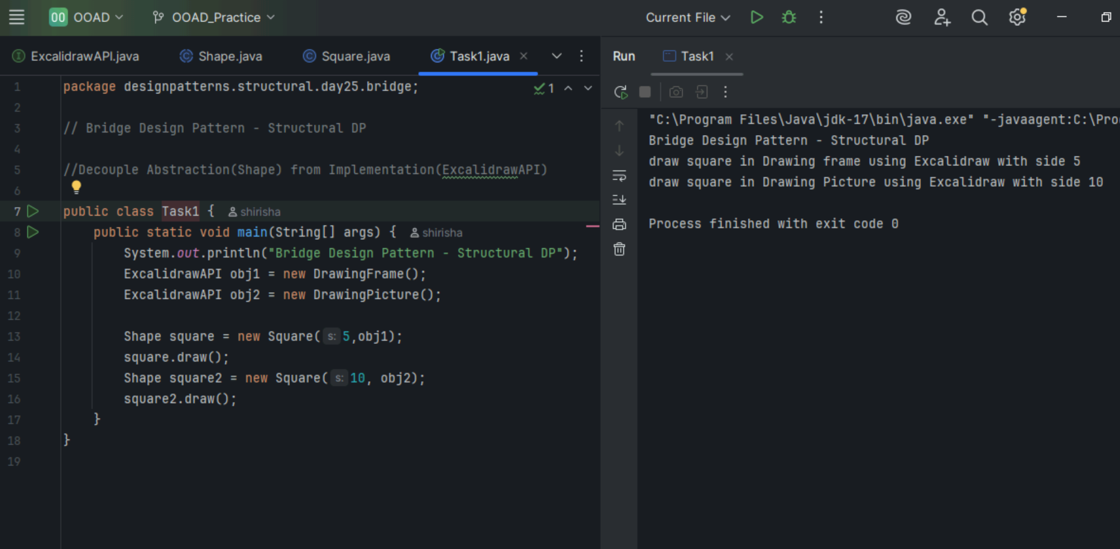

Task 2 : Composite Design Pattern - Structural DP - Company Hierarchy Example

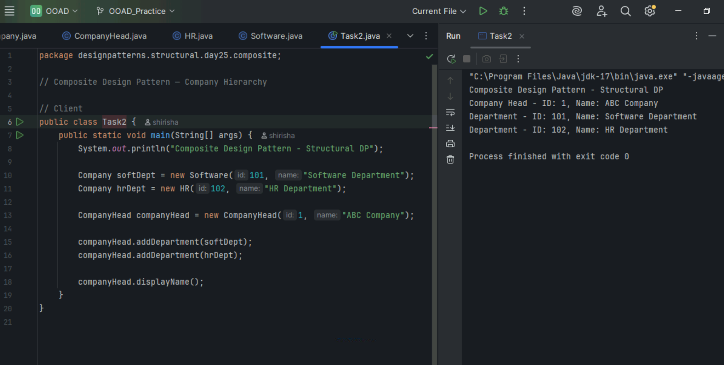

Task 3 - Façade Design Pattern – Structural DP - Payment and Shopping Façade Example

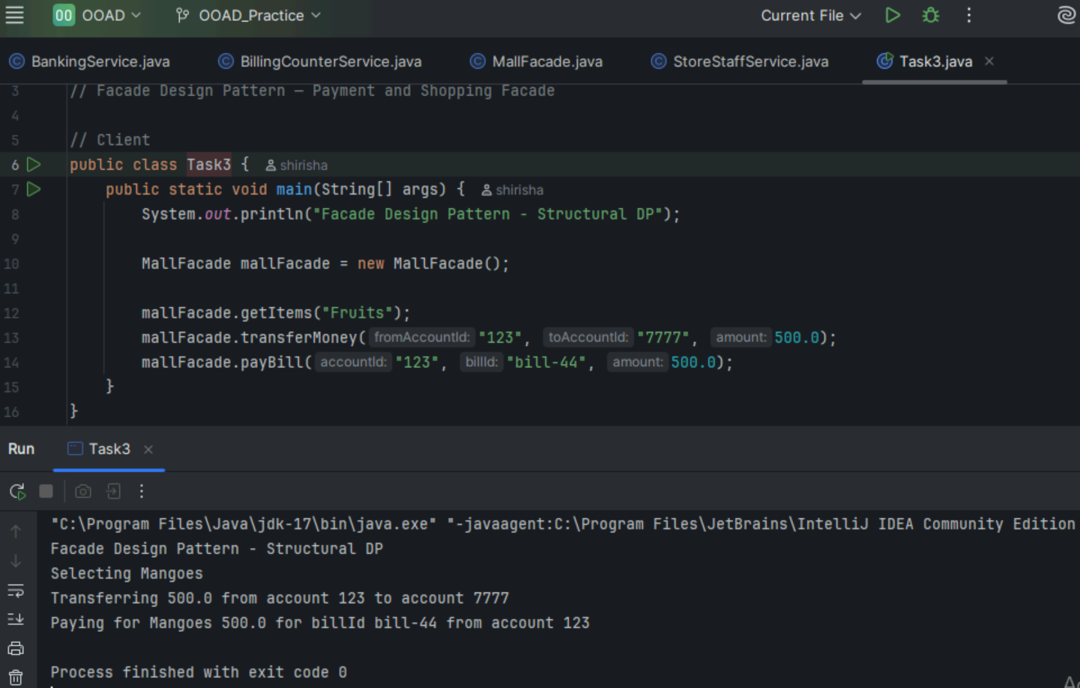

Task 4 – Proxy Design Pattern – Structural DP - Role-Based Database Operation Control

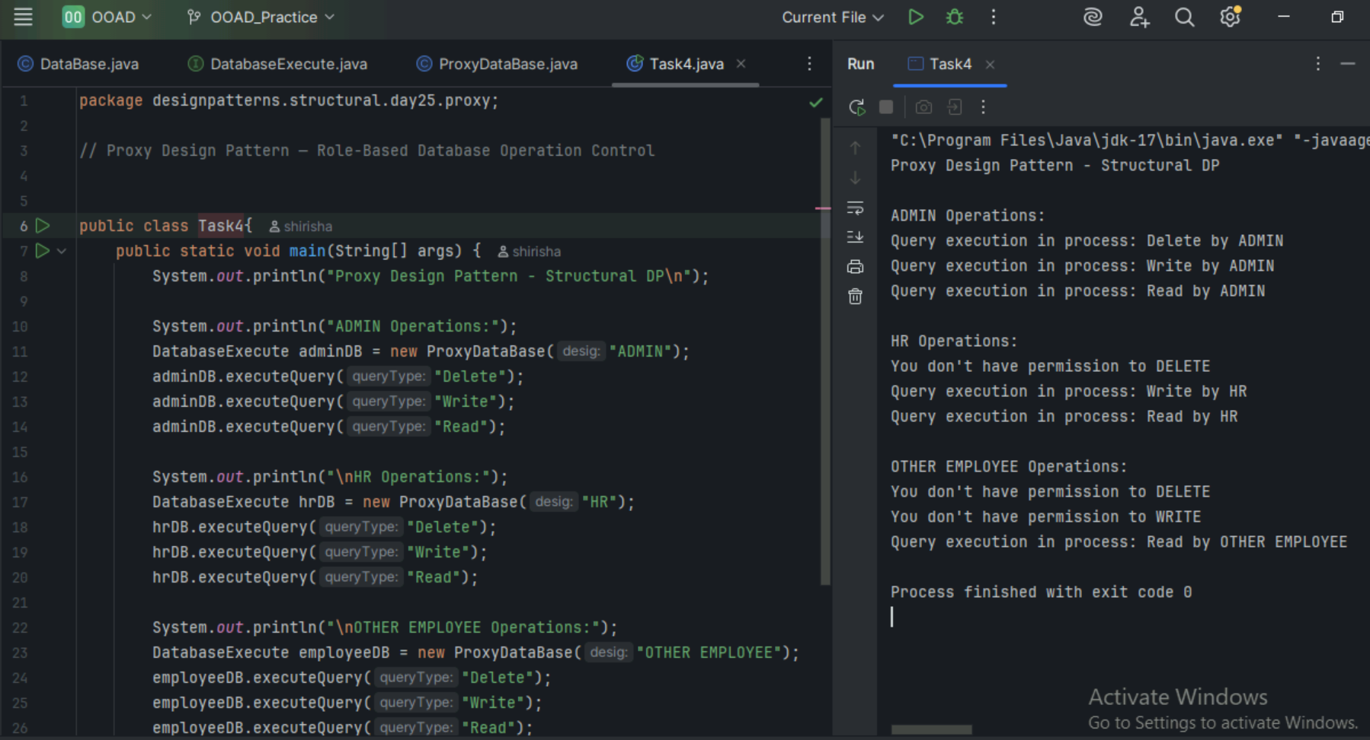

Behavioral Design Patterns

Task 5 – Command Design Pattern – Behavioral DP - Home Task Execution Example

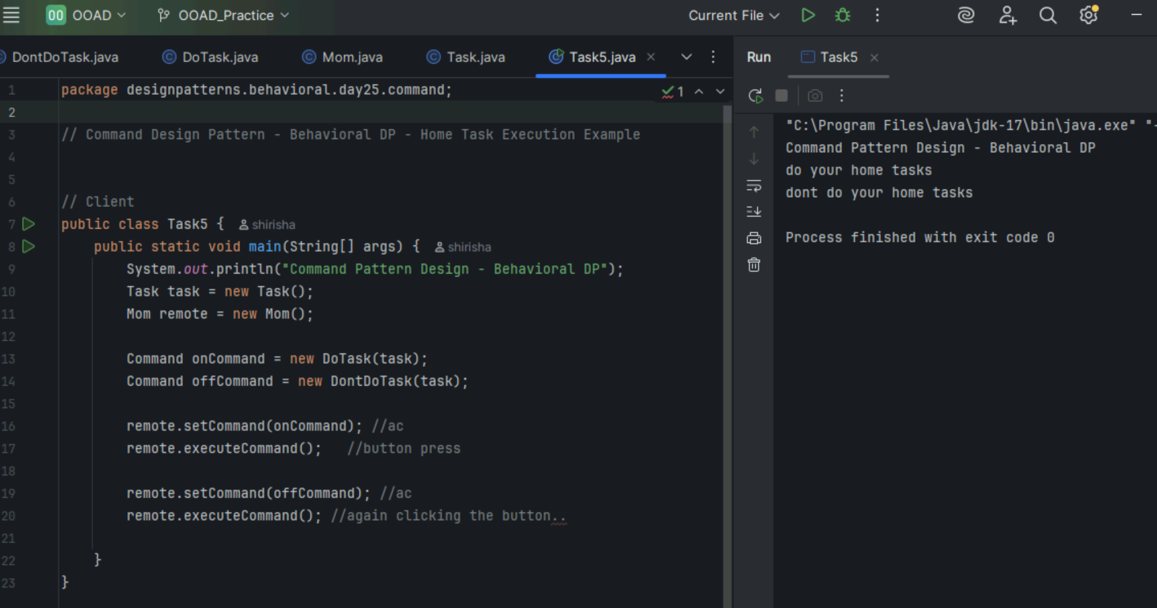

=========================================================================Home Tasks

=========================================================================

Task 6

Adapter DP – Structural DP - Laptop Charger Example

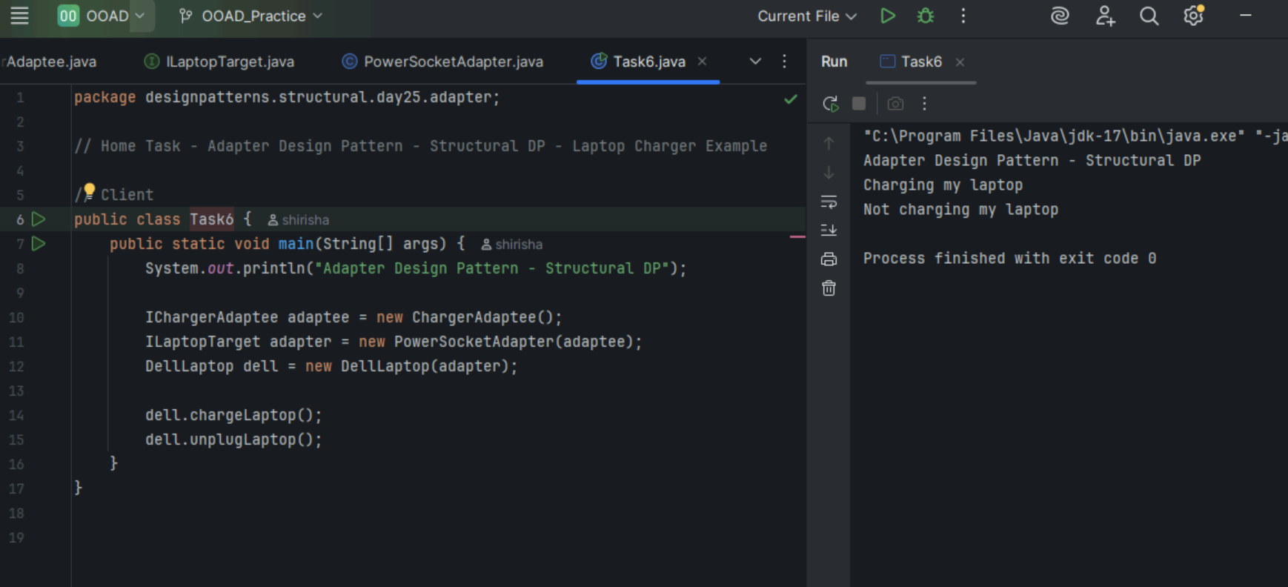

Task 7 – Decorator DP – Structural DP – Pizza Toppings Example

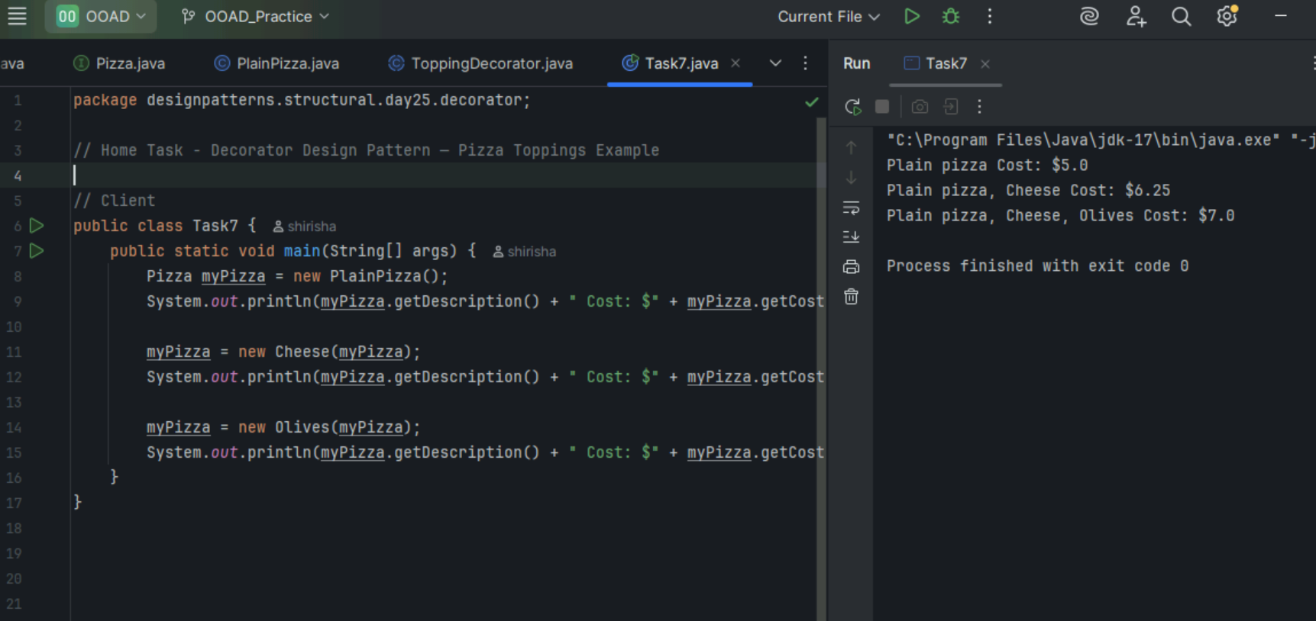

Task 8 – Flyweight DP – Structural DP – Reusing Circle objects based on color

